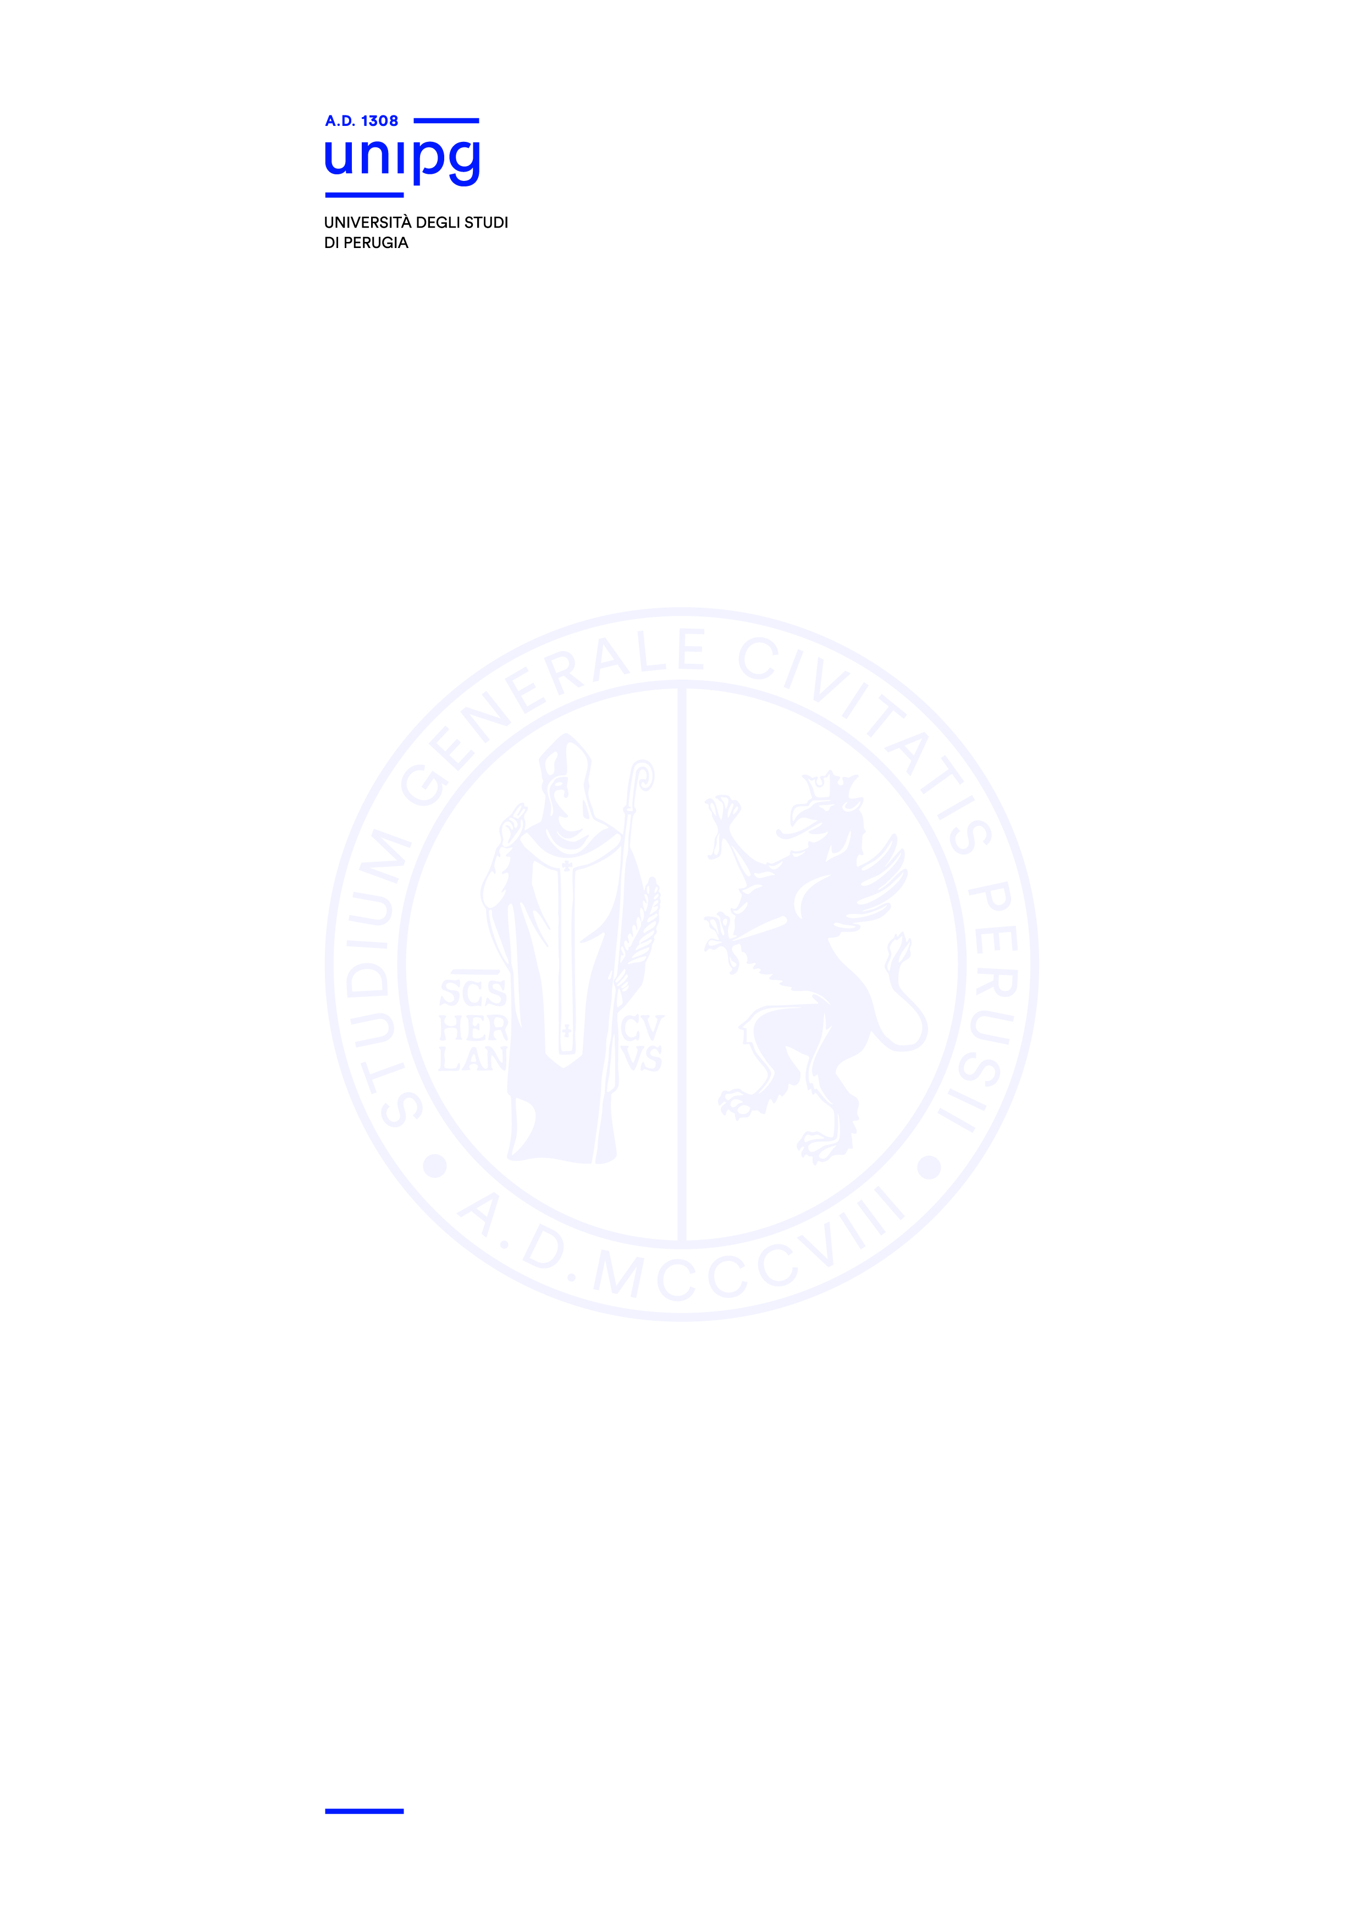

PUBLIC NOTICE
(as in art. 4 of the Selection Call)

RELATED TO PROCEDURES FOR COMPLETION OF THE SELECTION TEST FOR ADMISSION TO DOCTORAL PROGRAM COURSE in PHYSICS–2023/2024 ACADEMIC YEAR (1 PLACE FOR RESEARCH FELLOW - APPROVED BY D.R. N. 2348 of 26ST September 2023, published in Gazzetta Ufficiale IV serie speciale - Concorsi ed Esami no. 73 of 26 ST June 2023).

THE FOLLOWING SCHEDULE IS VALID AS A FORMAL NOTICE AND NO FURTHER PERSONAL COMMUNICATION WILL BE NOTIFIED.

Failing to attend the intervew in presence, or online, in case of online procedures, on the relevant day and time will be considered as a waiver by the candidate, whatever the cause.

For interviews in videoconferencing, candidates are asked to be provided with a webcam, a microphone and speakers (headphones equipped with a microphone are recommended) and are asked to have Microsoft Teams installed on their laptops (download available at the link https://www.microsoft.com/it-it/microsoft-365/microsoft-teams/download-app).

The interview will take place on 9th November 2023, from 9 am in the meeting room on the 3rd floor, at the Physics Department.

For candidates requesting it, interviews will be held in videoconferencing, by connecting to the following link:

https://teams.microsoft.com/l/meetup-join/19%3ameeting_ZjBlYTRjMGQtYzUzZC00M2E5LTkyMTUtZmQ0ZWU5ZWU4NWU2%40thread.v2/0?context=%7b%22Tid%22%3a%22067e7d20-e70f-42c6-ae10-8b07e8c4a003%22%2c%22Oid%22%3a%22493383b2-73a5-442e-84e4-7931d1931a2d%22%7d

